**Session-12 Assignment**

**Name:-** Aryan Dilipbhai Langhanoja

**Enroll No:-** 92200133030

**AIM**: To understand importance of DC operating Point on Load line and Fixed (Base) Biasing of transistor.

**Apparatus:**

1. Function generator
2. Dc power supply
3. Switch
4. Transistor (BC547)
5. Resistors
6. LED

**Task-1- Define Q point**

* Q-Point Is Defined is also known as operating point. The Point at which the circuit is operated is called a Q-Point.

**Task-2 Location of Q point for**

Active Mode: In the Middle.

Saturation Mode: Near to the Y-Axis.

Cutoff Mode: Near to the X-Axis.

**Task-3 Define Biasing and its importance**

* Biasing is a external DC Voltage given to the circuit in order to work it. And the importance of biasing is to the set Q-Point in the middle and to maintain the Q-Point in the middle of the load line.

**Task-4 Types of Biasing**

1. Base Bias
2. Collector to Base Bias
3. Emitter Resistor Bias
4. Voltage Divider Bias
5. Base Bias with Collector And Emitter Feedbacks
6. Emitter Bias with Two Supplies

**Task-5 Fixed (Base) Biasing of transistor**

**Sample Circuit diagram:**



Rc = 2.2 KΩ

Rb= 200 KΩ

Vcc = 12 V

C1=C2= 10 µF

Ac input signal: 5mVP sine of 1K Hz

**Important Relation:**

Vcc = VCE + ICRC

IB = (VCC – VBE) / RB

Vcc = VCE + ICRC

Vce = VCC - ICRC

IC = βIB

**Simulation circuit in Multisim:**

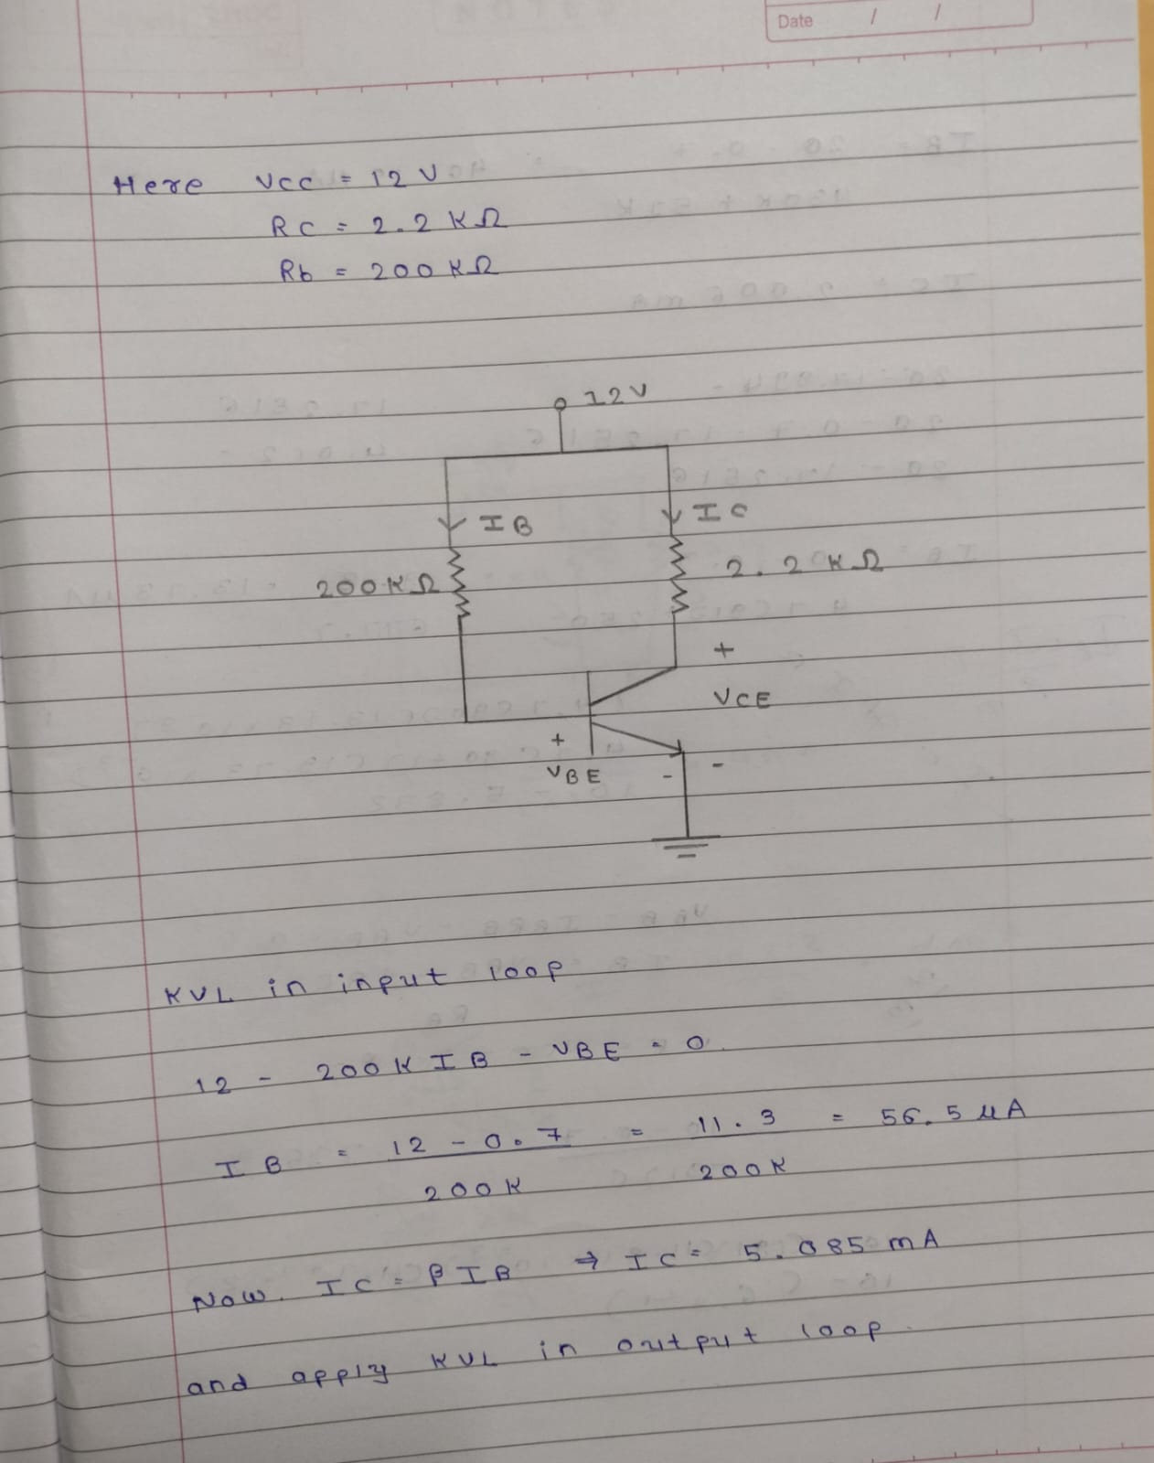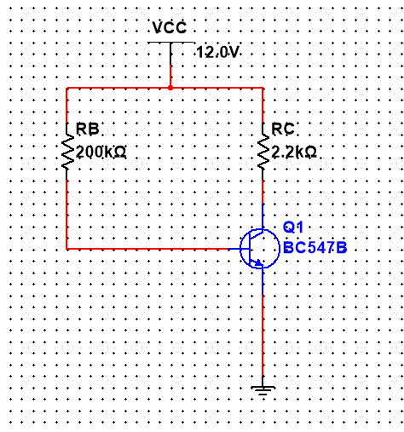

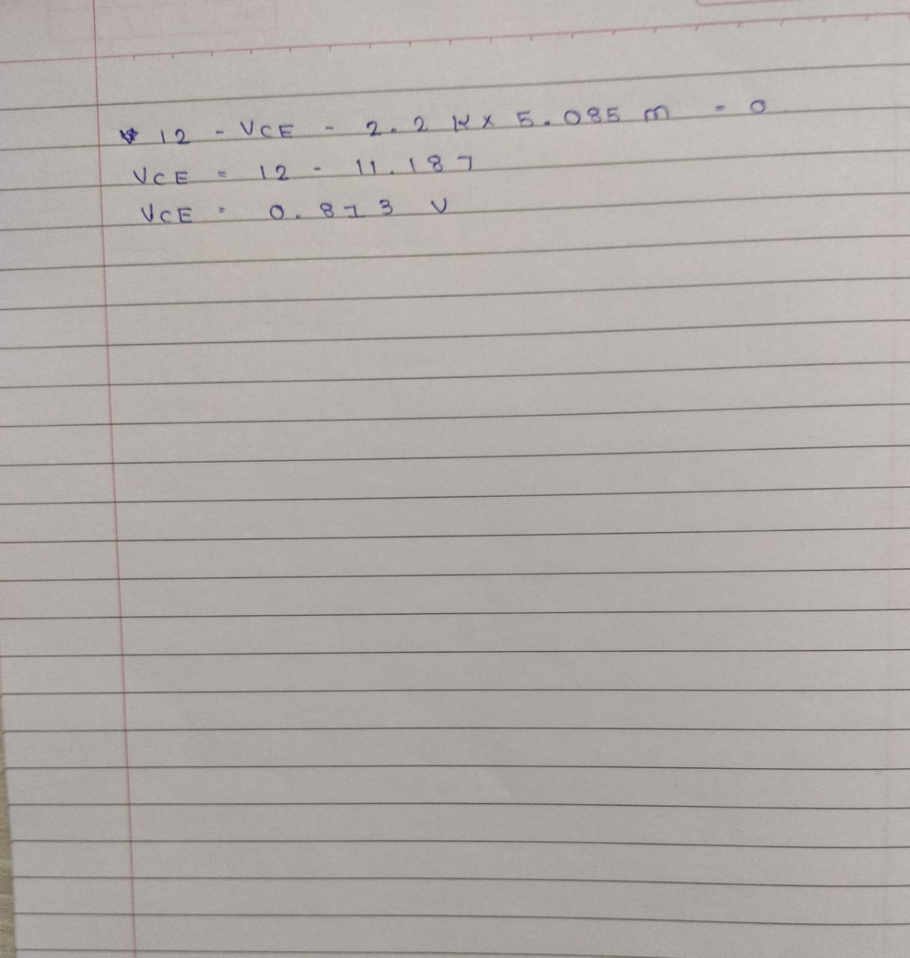

|  |  |  |  |  |
| --- | --- | --- | --- | --- |
| **Sr. No.** | **RB (KΩ)** | **IB (µA)** | **IC (mA)** | **β** |
| **1** | 500K | 22.657 | 4.901 | 216.3128 |
| **2** | 400K | 28.312 | 4.903 | 173.1775 |
| **3** | 300K | 37.76 | 4.979 | 131.8591 |
| **4** | 200K | 56.635 | 5.053 | 89.22045 |
| **5** | 100K | 113.252 | 5.214 | 46.03892 |
| **6** | 50K | 226.658 | 5.386 | 23.76267 |
| **7** | 10K | 1132 | 5.433 | 4.79947 |
| **8** | 5K | 2262 | 5.451 | 2.409814 |
| **9** | 1K | 11270 | 5.461 | 0.484561 |
| **10** | 0.5 K | 22475 | 5.462 | 0.243026 |

**Conclusion:**